2020 February 19 The Himalayan Times Page 1

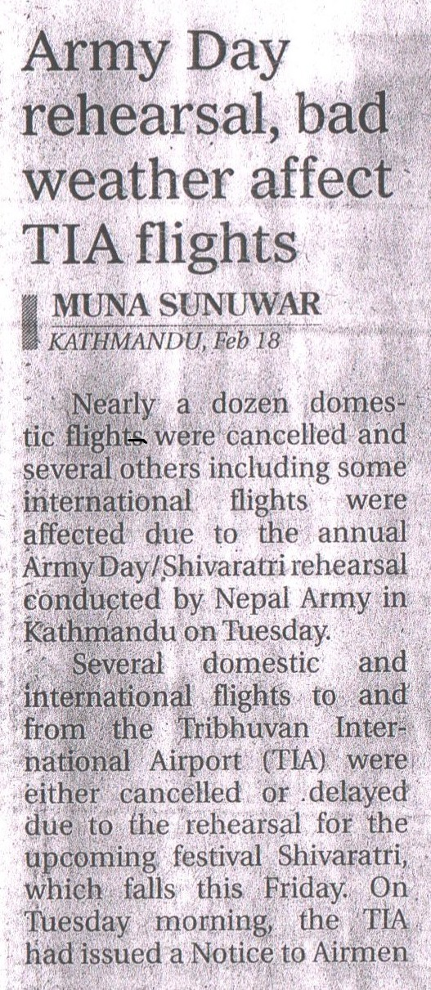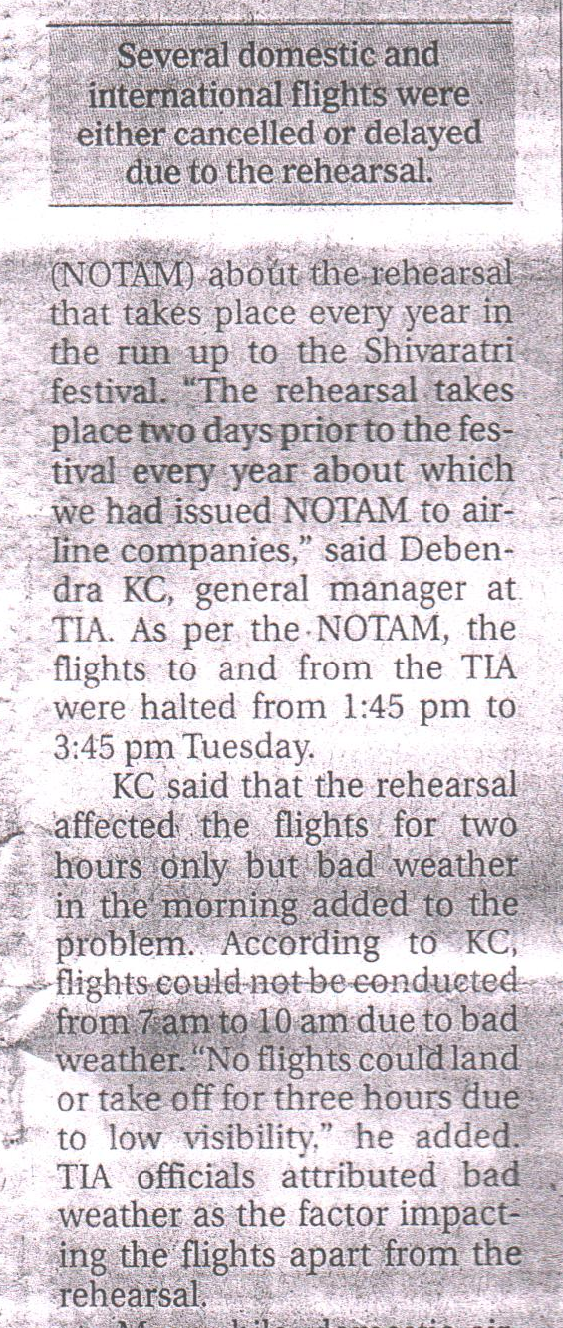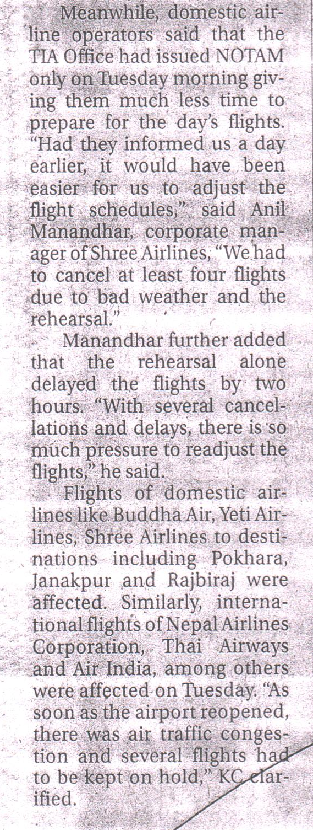

2020Feb19_Republica_ Army Day Rehearsal, Bad Weather Affect TIA